

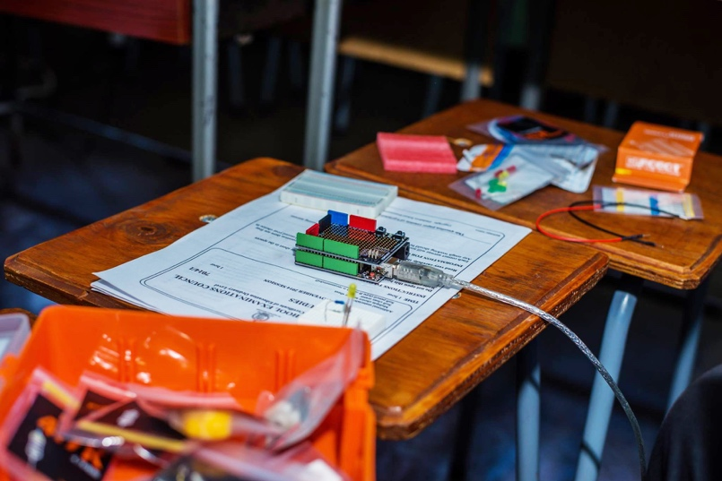

Insert Project Picture ofor TEAM

**Chapter Name  
Final or Interim Report?**

**Submission Date**

Insert Project Title

# Project information

# Project leader (indicate name and email)

# Team members (list the name of your peers – if available insert a team picture at the end of this section)

# Partner organizations

# Total amount awarded

# Period covered by this report

# 

# Project Summary

Write a short description of your project (200 words). You can refer to the summary that you wrote on your application.

It is recommended to complete this section once you have completed the report. It will be easier to write the summary based on highlights of the report you have just completed.

Insert a project picture on the side if available.

# Project Background and Justification

This report will be published in ISOC web site. So the reader understands the context of your project, please provide a brief description (150 words) about the situation/problem before the project stated and the motivation of the Chapter team to get involved to find a solution.

# Project Objectives

Please include the original project objectives. If these ones were modified during the reported period, please give a short explanation.

# Project Activities Completed so far

Please provide a list of activities undertaken by the the Chapter team to achieve project goals. Discussion of the performance to date against the goals of the project.

# Project outcomes

Please describe the project main outcomes/achievements so far.You can include here list of publications, materials, link to websites etc.

# Any changes in the design of the project

Sometimes project plans need to be changed, please report main changes and implications they may have for the continuation of the project. Will the next progress report or final report due date be affected?

# Dissemination and Chapter presence

Indicate how the project contributed to the Chapter presence and mission in the country/region so far. List events that you have participated on thanks to the project achievements. please include links here. Include links to articles where the project was mentioned.

Include project web site, Facebook page

How could other Chapters help you disseminate the project?

1. **Any additional information that would be useful to the Internet Society community for purposes of an interim report.**